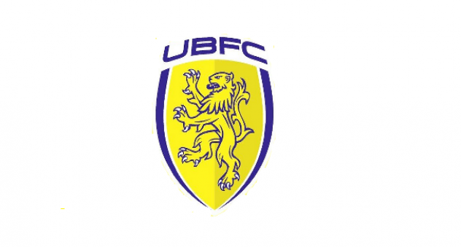

UPPER BEEDING FC

CODE OF CONDUCT

JUNE 2022

.

CODE OF CONDUCT FOR PLAYERS

Obligations towards the game

A player should:

1. Make every effort to develop their own sporting abilities, in terms of skill, technique, tactics and stamina.
2. Give maximum effort and strive for the best possible performance during a game, even if his team is in a position where the desired result has already been achieved or the game effectively lost
3. Set a positive example for others, particularly young players and supporters.
4. Avoid all forms of gamesmanship, and time wasting.
5. Always have regard to the best interests of the game, including where publicly expression an opinion on the game and any particular aspect of it, including others involved in the game.
6. Not use inappropriate or foul language

Players are reminded their responsibilities in respect of 5 and 6 above are
extended to include conversations/comments/opinions expressed on the pitch, off
the pitch or via social media accounts and are subject to the same Code of Conduct
expectation at all times.

Obligations towards the team
A player should:

1. Make every effort consistent with Fair Play and the Laws of the Game to help his own team win.
2. Resist any influence which might, or might be seen to, bring into question his commitment to the team winning.

Respect for the Laws of the Game and Competition Rules

A player should:

1. Know and abide by the Laws, rules and spirit of the game, and the competition rules.
2. Accept success and failure, victory and defeat, equally.
3. Resist any temptation to take banned substances or use banned techniques.

Respect towards Opponents
A player should:

1. Treat opponents with due respect at all times, irrespective of the result of the game.
2. Safeguard the physical fitness of opponents, avoid violence and rough play, and help injured opponents.

Respect towards the Match Officials

A player should:

1. Accept the decision of the Match Official without protest.
2. Avoid words or actions which may mislead a Match Official.
3. Show due respect towards Match Officials.

Respect towards Team Officials

A player should:

1. Abide by the instructions of their Coach and Team Officials, provided they do not contradict the spirit of this Code.
2. Show due respect towards the Team Officials of the opposition.

Obligations towards the Supporters

A player should:

1. Show due respect to the interests and safety of supporters.

CODE OF CONDUCT FOR TEAM OFFICIALS

Obligations towards the game
The team official should:

1. Set a positive example for others, particularly young players and supporters.
2. Promote and develop his own team having regard to the interest of the players, supporters and reputation of the national game.
3. Share knowledge and experience when invited to do so, taking into account the interest of the body that has requested this rather than personal interest.
4. Avoid all forms of gamesmanship.
5. Show due respect to Match Officials and others involved in the game.
6. Always have regard to the best interests of the game, including where publicly expressing an opinion of the game and any particular aspect of it, including others involved in the game.
7. Not use or tolerate inappropriate or foul language.

Team Officials are reminded their responsibilities in respect of 6 and 7 above are
extended to include conversations/comments/opinions expressed on the pitch, off
the pitch or via social media accounts and are subject to the same Code of Conduct
expectation at all times.

Obligations towards the team
The team official should:

1. Make every effort to develop the sporting, technical and tactical levels of the club/team, and to obtain the best results by the team using all permitted means.
2. Give priority to the interests of the team over individual interests.
3. Resist all illegal or unsporting influences, including banned substances and techniques.
4. Promote ethical principles.
5. Show due respect to the interests of players, coaches and other officials, at their own club/team and others.

Respect towards the Match Officials
The team official should:

1. Accept the decision of the Match Official without protest.
2. Avoid words or actions which may mislead a Match Official.
3. Show due respect towards Match Officials.

Obligations towards the Supporters
The team official should

1. Show due respect to the interests of supporters.

CODE OF CONDUCT FOR COACHES

1. Coaches must respect the rights, dignity and worth of each and every person and treat each equally within the context of the sport.
2. Coaches must place the well-being and safety of each player above all other considerations, including the development of performance.
3. Coaches must adhere to all guidelines laid down by governing bodies.
4. Coaches must develop an appropriate working relationship with each player based on mutual trust and respect.
5. Coaches must not exert undue influence to obtain personal benefit or reward.
6. Coaches must encourage and guide players to accept responsibility for their own behaviour and performance.
7. Coaches must ensure that the activities they direct or advocate are appropriate for the age, maturity, experience and ability of players.
8. Coaches should, at the outset, clarify with the players (and, where appropriate, parent) exactly what is expected of them and also what they are entitled to expect from their coach.
9. Coaches must co-operate fully with other specialists (e.g. other coaches, officials, sports scientists, doctors, physiotherapists) in the best interests of the player.
10. Coaches must always promote the positive aspects of the sport (e.g fair play) and never condone violations of the Laws of the Game, behaviour contrary to the spirit of the Laws of the Game or relevant rules and regulations or the use of prohibited substances or techniques.
11. Coaches must consistently display high standards of behaviour and appearance.
12. Not to use or tolerate inappropriate or foul language.

Coaches are reminded their responsibilities in respect of 11 and 12 above are
extended to include conversations/comments/opinions expressed on the pitch, off
the pitch, the training ground or via social media accounts and are subject to the
same Code of Conduct expectation at all times.

CODE OF CONDUCT FOR PARENTS / SPECTATORS

Parents/Spectators have a great influence on children’s enjoyment and success in football. All children play football because they first and foremost love the game – it’s fun. It is important to remember that however good a child becomes at football within your club it is important to reinforce the message to parents / spectators that positive encouragement will contribute to:

• Children enjoying football.
• A sense of personal achievement.
• Self – esteem.
• Assist to improve the child’s skills and techniques.

A parents/spectators expectations and attitudes have a significant bearing on a child’s attitude towards:

• Other players.
• Officials.
• Managers.
• Spectators.

UBFC wish to ensure that parents/spectators within the club are always positive and encouraging towards all of the children not just their own.

UBFC would like to encourage parents / spectators to:

• Applaud the opposition as well as their own team.
• Avoid coaching the child during the game.
• Not shout and scream.
• Respect the referee’s decision.
• Give attention to each of the children involved in football not just the most talented.
• Give encouragement to everyone to participate in football.
.
Parents/spectators are reminded their responsibilities extend to include
conversations/comments/opinions expressed on the pitch, off the pitch, at a match
or training session or via social media accounts and are subject to the Code of
Conduct expectation at all times.

UBFC would like to ensure that all parents / spectators within the club agree and adhere to this code of conduct and our Safeguarding Policy

