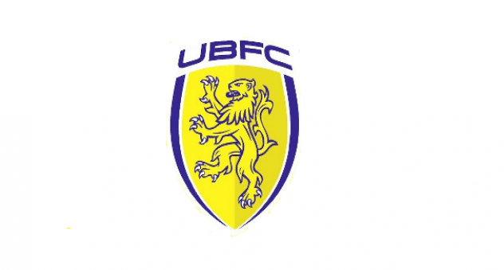
ANNUAL GENERAL MEETING
TUESDAY 27 JUNE 2022, 8:00PM
At UPPER BEEDING MEMORIAL FIELDS

AGENDA

1. WELCOME

2. APOLOGIES FOR ABSENCE/ CONFIRM QUORUM

3. ACCEPT AND SIGN MINUTES OF AGM 30th JUNE 2022

4. MATTERS ARISING

5. CHAIRMANS REPORT

6. TREASURERS REPORT - RECEIVE AND CONFIRM THE ANNUAL ACCOUNTS OF INCOME AND EXPENDITURE TO 31 MAY 2023

7. ADOPT UPDATED CLUB CONSTITUTION AND POLICY DOCUMENTS

8. ELECTION OF OFFICERS. TO CONFIRM APPOINTMENTS FOR 2023/24

Life Members – no changes proposed
President – no nominations, the position to remain vacant and kept under review.
Club Chairman – currently Jamie Plummer
Vice Chairman – currently Tom Warren
Treasurer – currently Jamie Plummer
General Secretary – currently Dave Rowland
Junior Secretary – N/A
Minutes Secretary - currently covered on a rota basis
Club Welfare Officer – currently David Beatty
Club Auditors – currently Richard Thomas

9. AWARD OF
- PETE ASHDOWN TROPHY FOR OUTSTANDING CLUB CONTRIBUTION
- UBFC TEAM OF THE YEAR

10. ANY OTHER BUSINESS

